**REPORT**

**ON**

**INDUCTION PROGRAM**

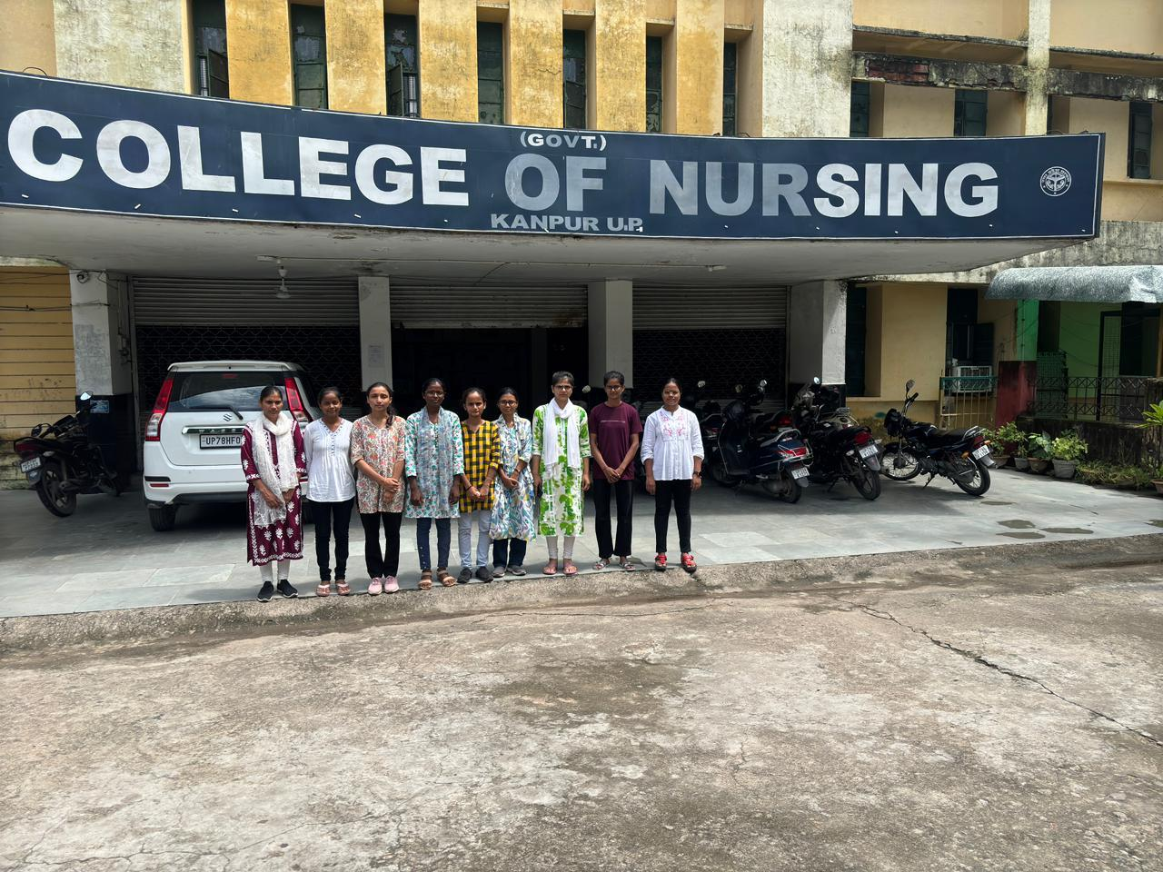

**DATE: 1/08/2024 - 3/08/2024**

**VENUE: COLLEGE OF NURSING, KANPUR**

**TIME: 9:00 AM- 4:00 PM**

**College of Nursing, GSVM Medical College Kanpur**

**Induction Program**

**Post Basic BSc Nursing 1st year [2024-2025]**

Nursing is the most humble and grounded profession where every year hundreds of students take admission in different colleges across the country to shape their carriers in nursing.

College of Nursing, Kanpur had organized a 3-day induction/orientation program for the new joining students in Post Basic BSc (Nursing) 1st year batch 2024-2025. The session commenced on 1st August 2024.

Cordinators of Post Basic BSc(N) 1st Year 2024-2025:

* Mrs. Renu Tripathi : Coordinator
* Mrs. Itisha Rose Prasad: Co-coordinator

Induction Program:

**Day 1- [01/08/2024]:**

* Reporting and joining of students by Mrs. Renu Tripathi and Mrs. Itisha Rose.
* Orientation about the academic policies, rules and regulations by Prof. Namita Batra

On day 1, 10 students joined in P.B.BSc 1st Year. The admission form and joining letters were received by Mrs. Itisha Rose.

After which, Students were oriented with the academic policies, syllabus, attendance requirement, assignment completion, scholarship by Prof. Namita Batra.

**Day 2- [02/08/2024]:**

* Orientation about the examination schemes and requirements by Asso. Prof. Mr. Subhash Sharma
* Orientation to the Clinical Site LLR & Associated Hospitals by Mrs. Itisha Rose
* Orientation of the College, hostel and Library by Mrs. Itisha Rose

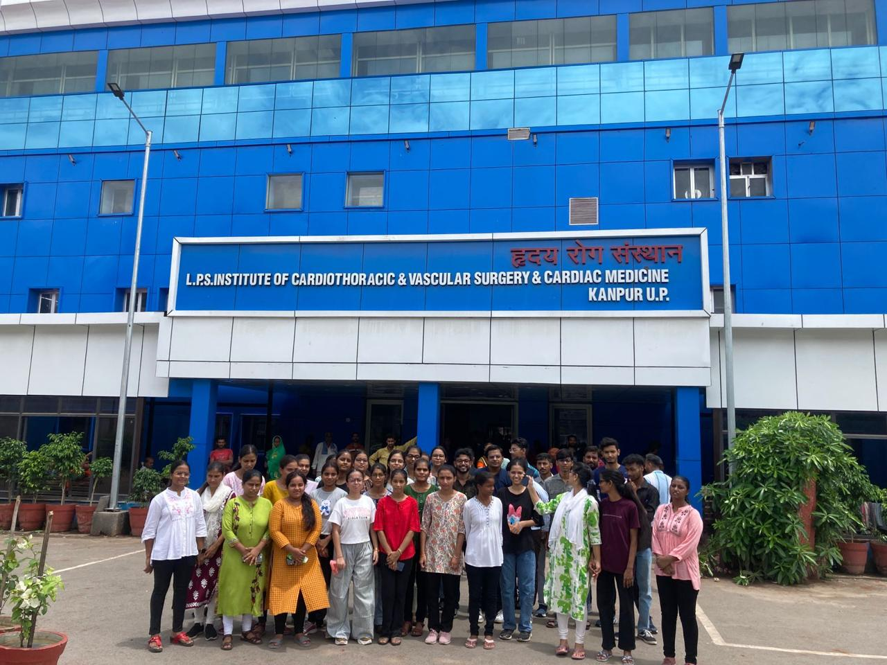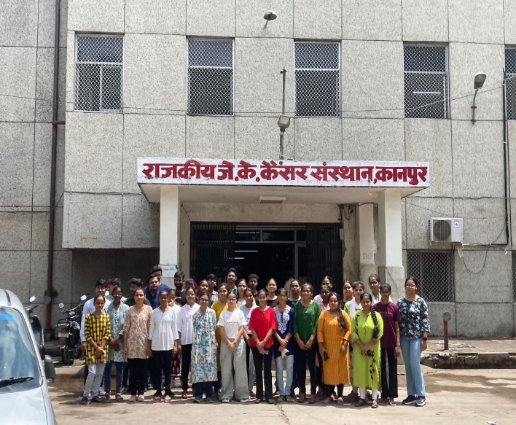**Pictures of Day 2:**

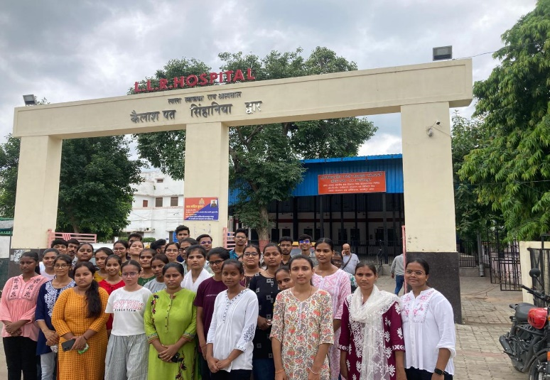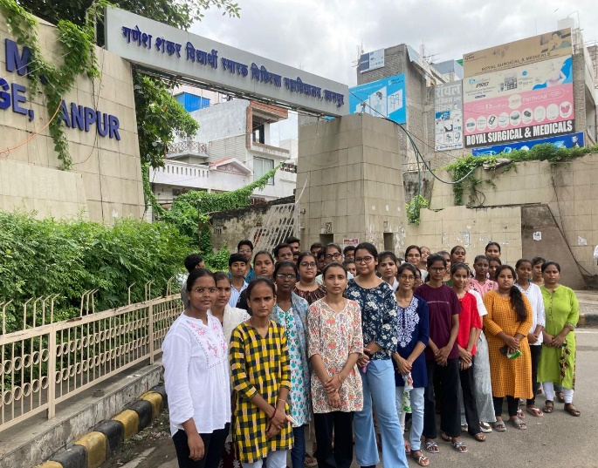

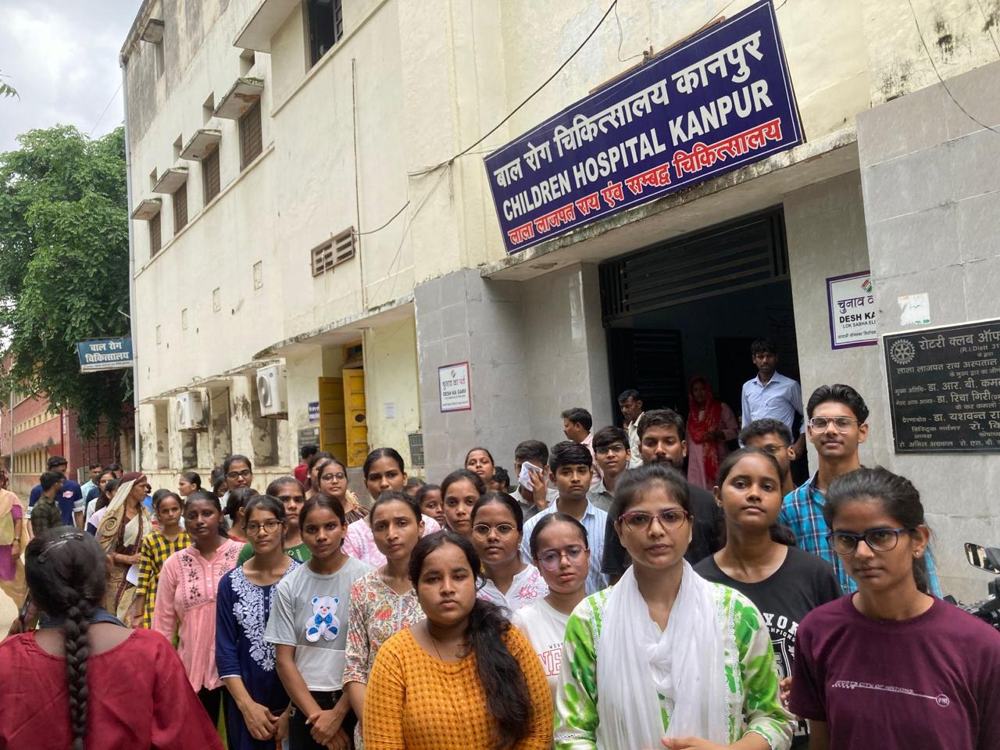

**Day 3- [03/08/2024]:**

* Interaction with principal and all other faculties.
* Orientation to different subjects and the syllabus by respective subject incharges.

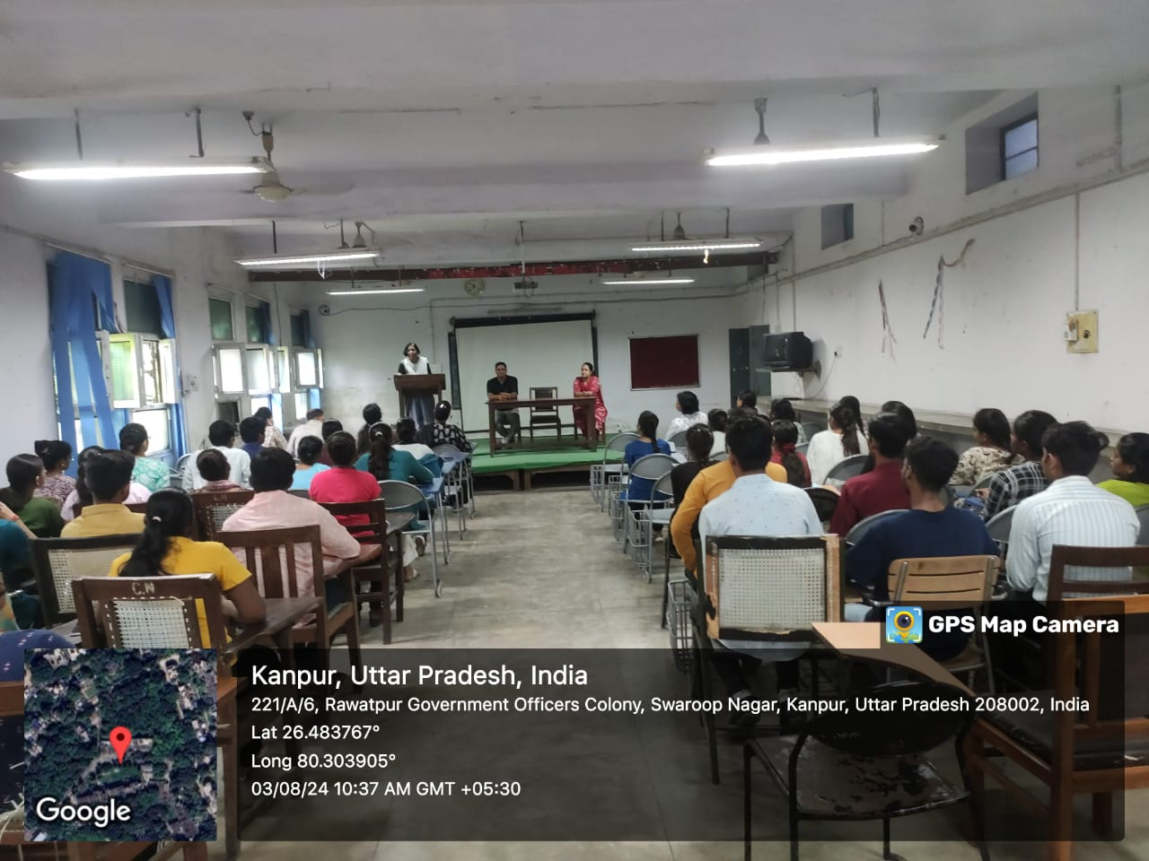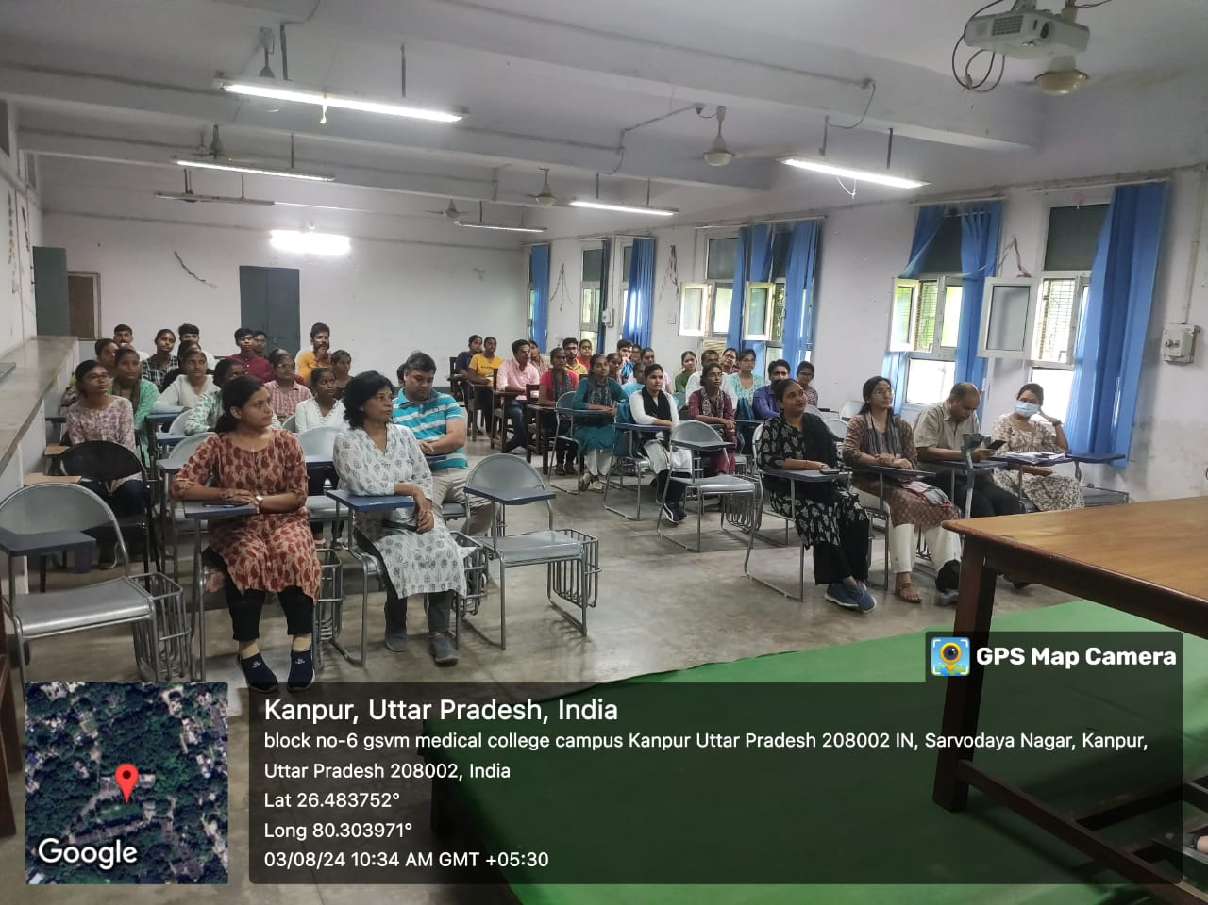**Pictures of Day 3:**

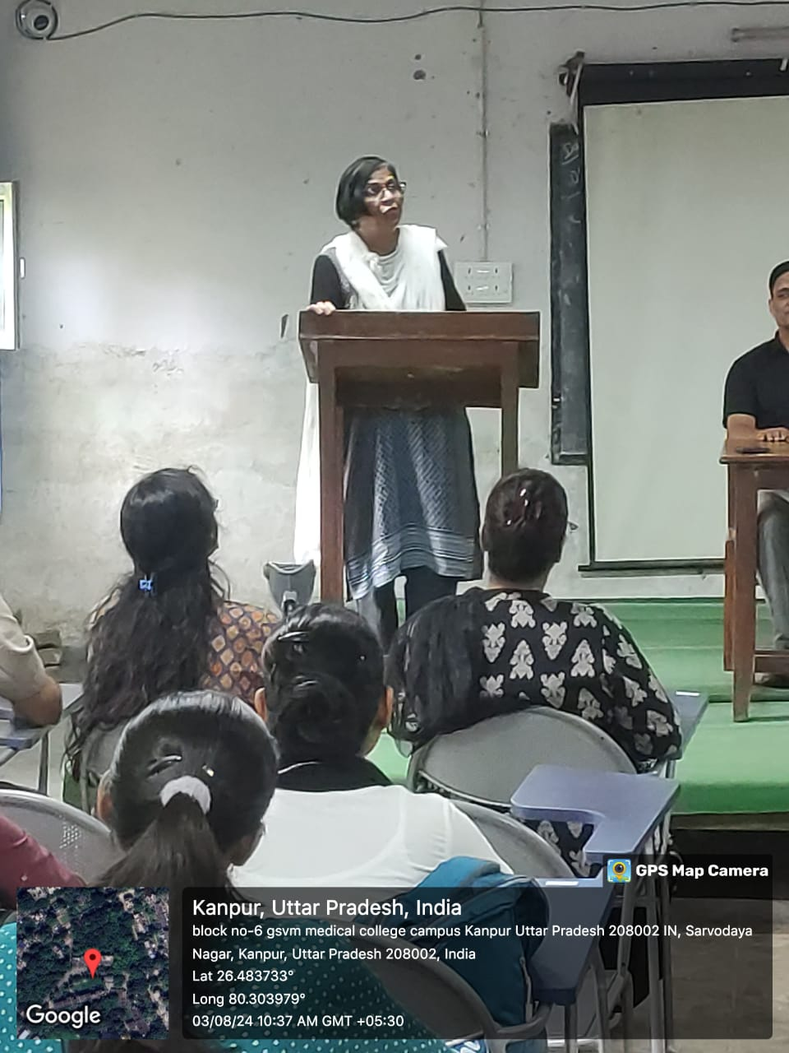

At the time of interaction with principal and faculties, students were welcomed by principal mam and Asst. Professor Dr. Ram Kumar Gupta Sir. Principal mam shared her experiences and motivated the students to work effortlessly and encouraged them to be active in studies and extra-curricular activities to have an overall improvement in personalities. Mam, even encouraged the students to become kind, humble nurses and be fruitful for the nation.

And thus 3 days induction programme for the new joining students ended on a good note.